elastic

wp2ss2xAxTY5UnRUdgo2tUgW

Why Kibana ?

Easiest way of running queries is using Kibana tool. It also sends requests to Elastic search API.

It formats the response for us and makes it easier to read.

It also sets the correct-content type header.

Auto typing.

Postman / Curl can also be used.

1. GET /_cluster/health

_cluster is the api

health is the command

2. _cat api which outputs data in a human readable format.

_cat/nodes : all nodes in the cluster

command :

GET /_cat/nodes?v

v : query parameter : instructs elastic search to include a descriptive header in the output- to identify each piece of info

o/p:  
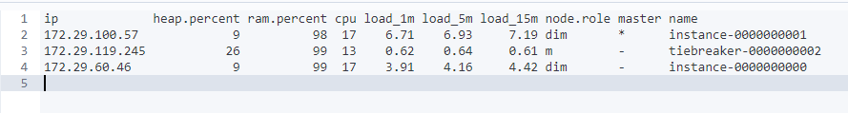

3. GET /_nodes/stats

API : nodes

To inspect nodes in a lot of detail.  
  
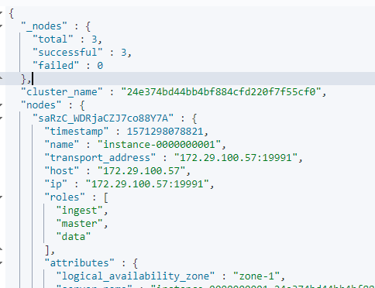

4. GET /_cat/indices?v

curl -XGET "http://24e374bd44bb4bf884cfd220f7f55cf0.containerhost:9244/_cat/indices?v"

List all indices  
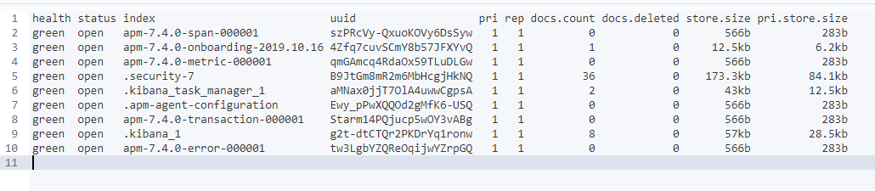

If its elastic cloud : we can send elastic search requests with the CURL http client

curl –XGET –u elastic: wp2ss2xAxTY5UnRUdgo2tUgW ‘<https://24e374bd44bb4bf884cfd220f7f55cf0.ap-southeast-1.aws.found.io:9243/.kibana/_serch> –H “Content-Type: application/json” –d { “query” : { “match_all”:{} }}’

5. Sharding and scalability.

Elastic search has a cluster with nodes.

Each node has a capacity and you can store 200gb of data in 2 nodes each having 100gb of data.

Sharding : Makes it possible to scale the amount of documents we can store.

It’s a way to divide indices into small pieces called shard[any number of shards] – done at index level.  
 Indices could contain a few hundred records to a million records.

To horizontally scale the data volume, indices are divided into shards.

[ If an index has 5 shards : There is no need that all shards be in different nodes – they could be in the same node as well. ]

**Advantage of having shards**: Search query on an index can be run independently on different nodes – increasing the speed of output [as shards could be stored in different nodes.].

Sharding : it is a process to sub divide an index in smaller pieces.

: it increases the number of documents an index can store.

6. Get /cat/indices?v  
  
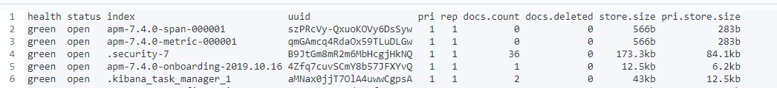

Pri – primary shard : the number of shards a given index has.

spilt api : to increase the number of shards in an index.

shrik api : to reduce the number of shards for an index.

7. Replication.

- it is configured at the index level

- Copies of shards are created – replica shards.

- When an index is created we can choose how many replicas of each shard we want. 1 being the default.

- Replica shard is never stored in the same node.

- Throughput can be increased as the query is distributed.

8. snapshot: to store an index completely.

Used for daily backup, manual backups are taken just before applying changes – just to be sure the changes are good.

9. Create and Index: PUT /indexname

10. Check the cluster Health: GET /_cluster/health  
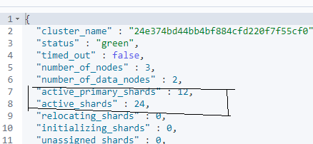

The cluster health is **green** as there is replication of shards.

11. check the shards : GET /_cat/shards?v  


p- primary shard.

r – replica shard.

state = STARTED: both primary and replica shards are available for requests.

12. different roles of a node.

Master node :

Data node :

Ingest Node : This enables a node to run Ingest pipelines.

Node.ml : identifies a node as machine learning

Xpack.ml.enabled : Determines if the node should respond to machine learning requests.

Co-ordination node : how ES process a request and delegates it internally to data nodes[by removing other roles – no role exists., kind of a load balances].

13. Roles of our nodes ?

Command : GET /_cat/nodes?v

o/p :



dim – data ingest and master

m - master

14. ES exposes a rest API.

- HTTP verb is important to perform a particular action.

DELETE AN INDEX :   
  
CREATE AN INDEX by specifying the number of shards and replicas. [ For indices that we use to create for production purposes we should stick to the default values ]  
first line : http verb + end point

Other lines : *json request body* AND *index settings* should be passed as a json object

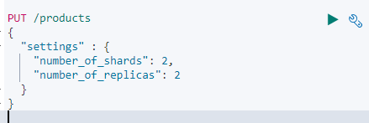

15. INDEXING A DOCUMENT BY sending a request to an end point.

*- we need to define the document within the request body as a json object*

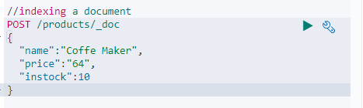

o/p :   
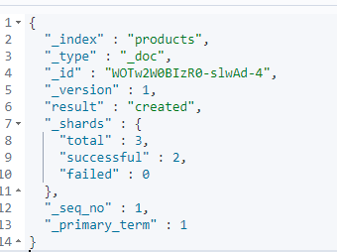  
  
_shards : The number of shards in which you successfully stored a document.  
In step 14 : replics are 2, so document was added to primary and also to the 2 replicas so total is 3.

_id : was created automatically but we can add that too.

16. Add _id while indexing a document.

To specify an id : we need to change the http verb to **PUT** as this is a convention for REST api.  
  
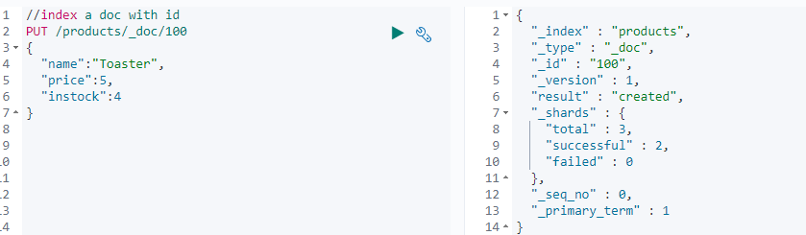

17. Retrieving documents from an index.  
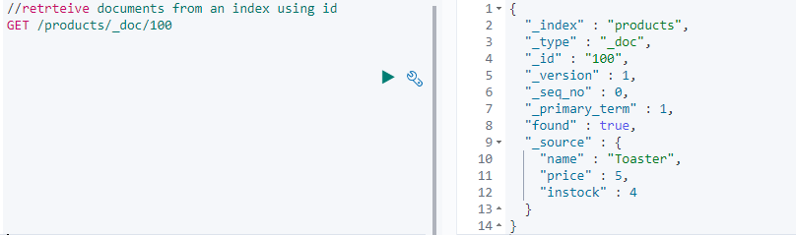

18. Updating documents: by sending a update request   
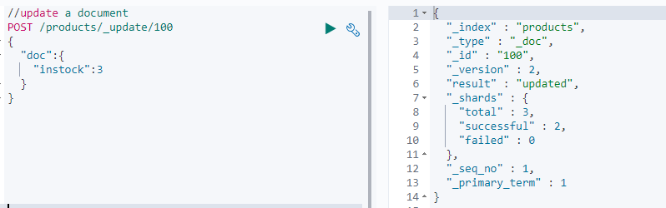

19. Adding new fields to existing documents.  
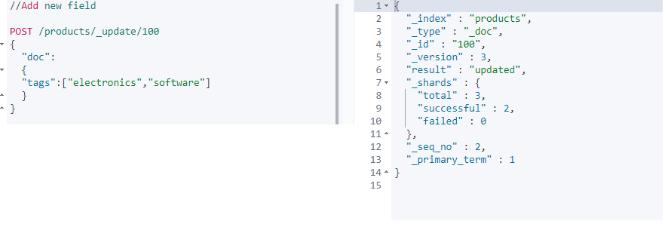

Now we see the new field with data.

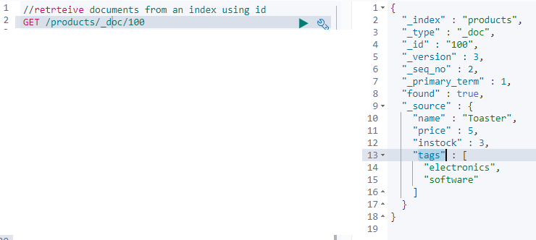

How this works internally.

* ES documents are immutable (!).
* The _update api : retrieved the document/changed its fields/re-indexed the document with the same id.

20. Scripted updates

- There is a use case where you retrieve a document first + update a field value + update the document.

- all of this can be done in one go.

- with scripting : we can use if statements

- use the _update api + script update with the request body

Example :

ctx: it is a ES variable and ‘short for context’.

_source: access the source document using the _source property, which gives us an object containing the objects fields.  
  
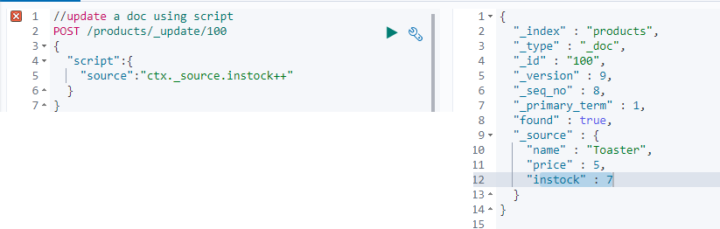

* We can do assignments also apart from updating a field.  
    
  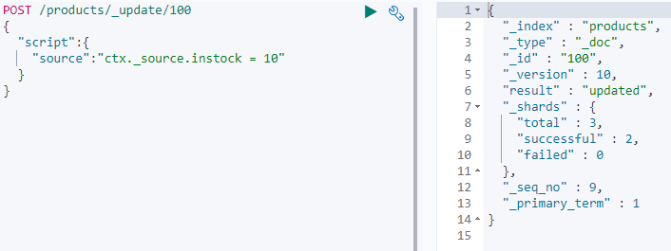
* Now if some customer purchases 4 products, the application must send a request to reduce the instock count by 4.
* We use this by writing a params object and using its value to reduce the count

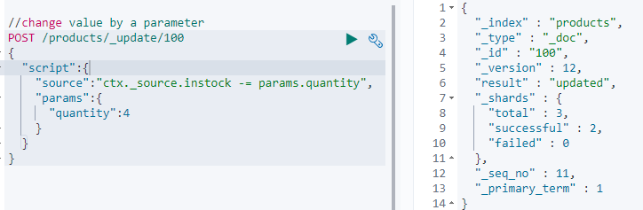  
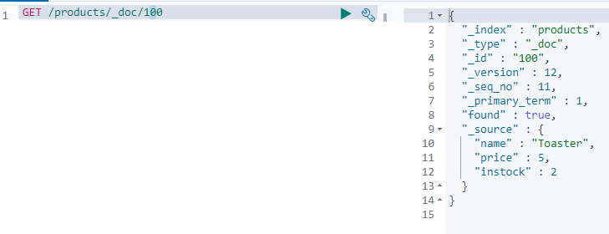

* If you try to update a field value with its existing value : result will be “no-op” else updated
* If the field value is set as part of a script the ”result” will always be as “updated”
* There are 2 exceptions to this – both being if we explicitly set the operation within the scripts.

Case 1 : A script to ignore a document based on a condition – by setting the **op** property on the **ctx** variable to “noop”.

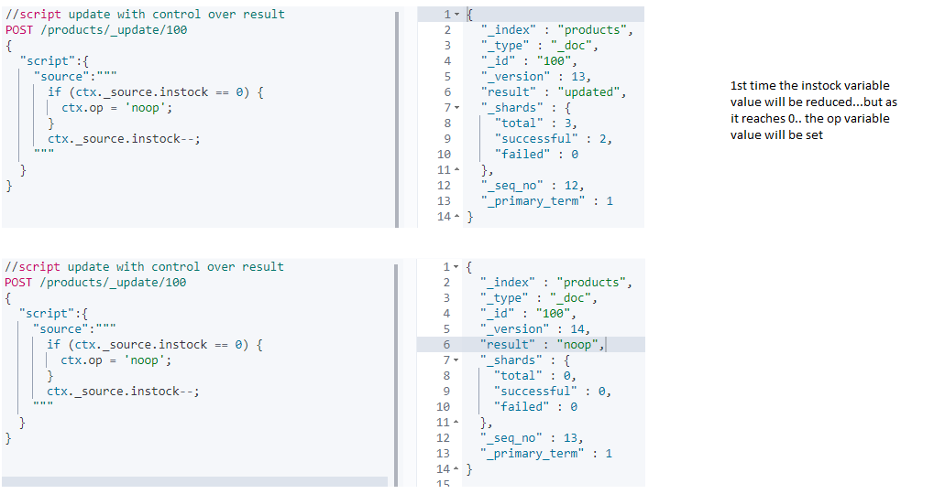

What the above script does is reduce the instock field value in the doc by 1 and set the resultkeyto ‘updated’; if it is zero the **result** key will be set to a value of ‘noop’

Case 2 :  
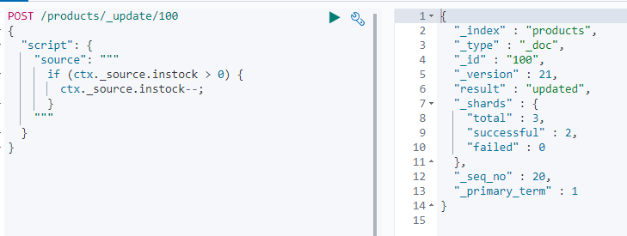

Ir-respective of the execution of the if block : the result will always contain “updated”

If you want to detect if nothing was changed then : follow case 1.

Case 3 : We can set the operation to delete which will cause the document to be deleted.  
This will set the result key to deleted with in the results.

**ctx.op = ’delete’;**

21. Updating documents using upserts

Insert if not present or else update it.

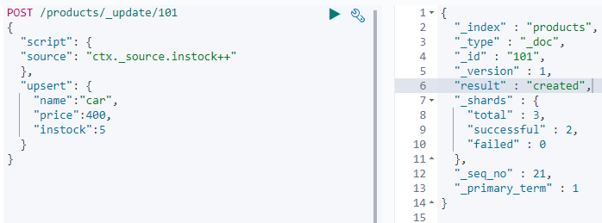

The instock is 5 after creation.  
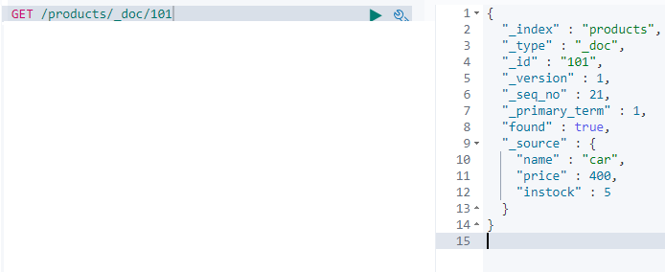

If the POST query is run again : **"result" : "updated".**

So, The script is run if the document exists else the upsert is run.

22. Replacing documents.

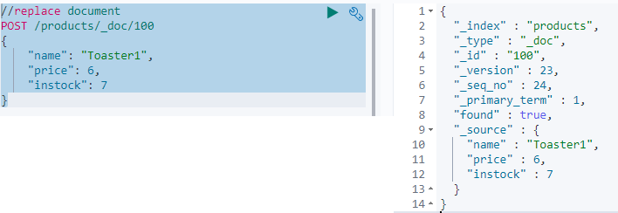

As the whole document was replaced if any other field existed in the old document they will not still exist.

23. DELETE documents  
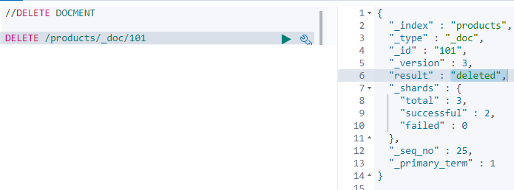

24. How ES reads data ?

- its about reading a single document.

- a given node receives the read request.

- this node is responsible for co-ordinating the request – so its called the co-ordinating node.

- locate where the document is stored -> that’s done with routing.

- with Routing : Routing resolves to a shard that stores a given document.

- i.e : It resolves to a primary shard or a replication group [contains the list of primary shards + its replica groups]

- Note : If elastic search directly retrieved the document from primary shard – all retrievals will end up in the same shard – which does not scale well : INSTEAD a shard is chosen from the replication group.

- So a technique called ARS : Adaptive replica selection is used.

- ES tries to select a shard copy it believes that can yield the best performance.

- then the co-ordinating node send the read request to that shard… and so on.

25. How ES writes data

- the request is resolved to a replication group that stores/SHOULD STORE the document.

- the write is always routed to the primary shard

- It validates the field values and structure of the request.

- The write op is performed in the primary shard before it fwds to the replica shards (this could be in parallell).

- Note that the operation succeeds even if the operation cannot be replicated to the replica shards.

> Since elastic search is distributed and many tasks happen asynchronously many things can go wrong.  
> When a document is indexed – the primary shard validates the operation and indexes the document locally  
> Assume there are 2 replicas in the replication group, then the primary shards send the operation to these two replicas.  
> Let us assume the operation reaches only 1 replica shard (RS1) – as the primary shard (PS) goes down due to a hardware failure.[PS RS1 RS2]  
> When this happens ES goes through a recovery process – In which one of the replica shard will be promoted as the new Primary shard [each RG must have a primary shard.]  
> Only one replica shard indexed the new document and other did not.  
> RS 2 thinks it is up to date – but this is not the case.  
> The new document will be found only half of the time – depending on which shard serves the request.

SO HOW ES solve this : primary terms + sequence numbers.

Primary terms (PT) :   
A way to distinguish between old and new primary shards, when the primary shard of a replication group has changed.  
The primary term for a replication group is essentially just a counter about how many times the primary shard has changed. [1 or 2 or 3]  
In the above case : The Primary Term for the RG will be increased by 1 as the primary shard failed and one of the replication shard was promoted to be the primary shard.  
The Primary terms for all Replication groups are persisted in the cluster’s state.  
When write operations are performed : the current PT is appended to the operations that are sent to the replica shards.  
This enables the RS to tell if the PS was changed since the operation was forwarded.

**Sequence Number**  
Apart from associating each operation with a primary term a **sequence number** is given to each operation.

This is also just a counter that is incremented for each operation – until the PS changes.

The primary shard is responsible for increasing this number when it process a write request.

These sequence numbers help ES to know in which order write operations happened, on a given primary shard.

Thus instead of comparing data on the disk – we can use PT and SN to figure out which operations have already been performed + which are needed to bring a given shard up to date.

[global checkpoints and local checkpoints are also imp]  
  
**Global checkpoints** : exists for each replication group.  
**Local Check Points** : kept for each replication shard.

It is the active sequence number that all of the active shards with in a replication group have been aligned atleast up to.

This means that any operations containing a sequence number lower than the global check point have already been performed on all shards with in the RG.

If a primary shard fails and re-joins the cluster at a later point : ES only need to compare the operations that are above the global check point that it last knew about.

Like wise : if a replica shard fails only the operations that have a sequence number higher than its local checkpoint need to be applied when it comes back.

THIS MEANS TO RECOVER ES JUST NEEDS TO COMPARE THE OPERATIONS WHILE THE SHARD WAS GONE , INSTEAD OF THE ENTIRE HISTORY OF THE REPLICATION GROUP.

26. **Optimistic concurrency control.**

We need our update to fail if the document has been modified since we have retrieved it.  
PT and SN are of use here.

When we retrieve the product - > PT and SN are included in the results.

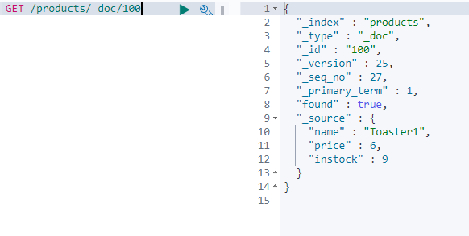

We take them and add them to the post request that we send to update the document.

Elastic search will use these two values and ensure a document will not be over written in-advertently, if it has changed since we retrieved it.

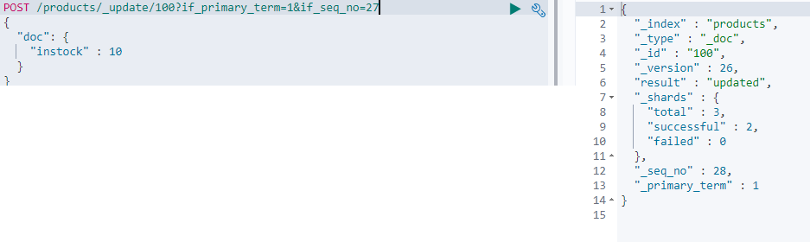  
  
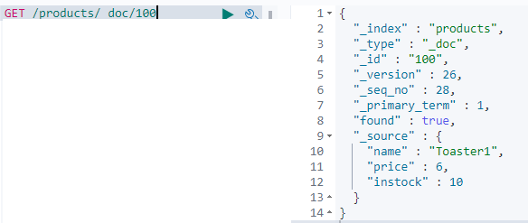

Let’s try to update with the same old seq num again  
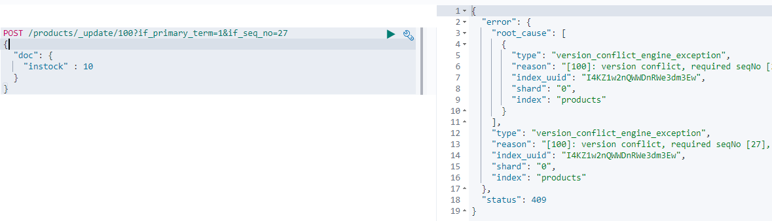

27. Update multiple documents with a query – how it works internally.

The first things that happens when an update by query request is processed :

* A snap shot of the index is taken.
* A search query is sent to each of the indexes shards – in order to find all of the documents that match the supplied query.
* Whenever a search query matches any documents – a bulk request is sent to update those documents
* “batches” : How many batches were used to retrieve the documents.
* A search and bulk request are sent sequentially.
* When a number of documents are updated when an error occurs : Those documents remain updated even though the request failed.
* The queries could run successfully against a Replication Group A, But something went wrong when sending queries to Replication Group B – causing the query to be aborted.
* Any documents that match the search query are therefore not updated within the replication group C.
* The documents that were updated with in the Replication Group A will remain updated even though the query was aborted.
* **The reason why EC takes a snapshot of the index** : it is to ensure that the updates are performed on the basis of the current state of the index.
* Let us say for an index where documents are indexed, modified and deleted frequently – it is not unlikely that something has changed, from when EC received a query to when it finishes processing it.
* This is especially true when updating many documents.
* When ES is requested to update a given document, it uses the documents PT and SN from the snapshot to ensure that it has not been changed since creating the snapshot.
* If the document has been changed – there will be a version conflict causing the document to not be updated.
* This will cause the entire query to be aborted.
* The number of conflicts will be returned with the ‘version_conflict’ key with in the results.
* If you don’t want the query to be aborted – what the below one does is it will cause the version conflicts to be counted instead of the query being aborted.  
  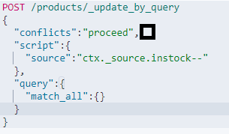

28. Update multiple documents with a query. API : _update_by_query  
First find all the documents in the index products  
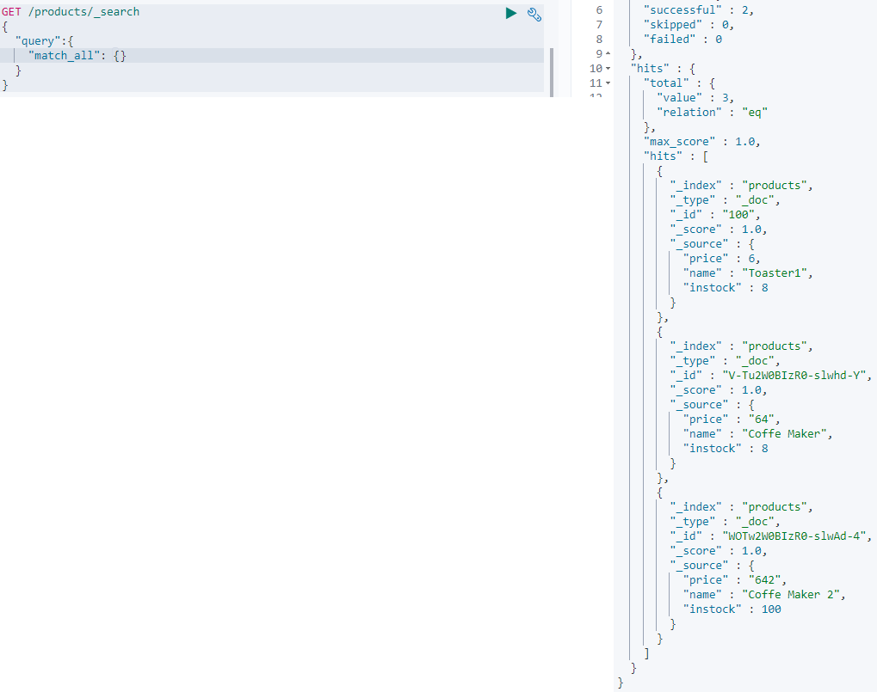

Now lets update them

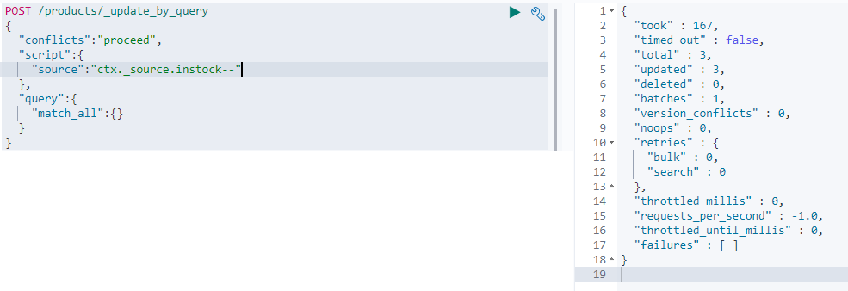

Lets see the results again.

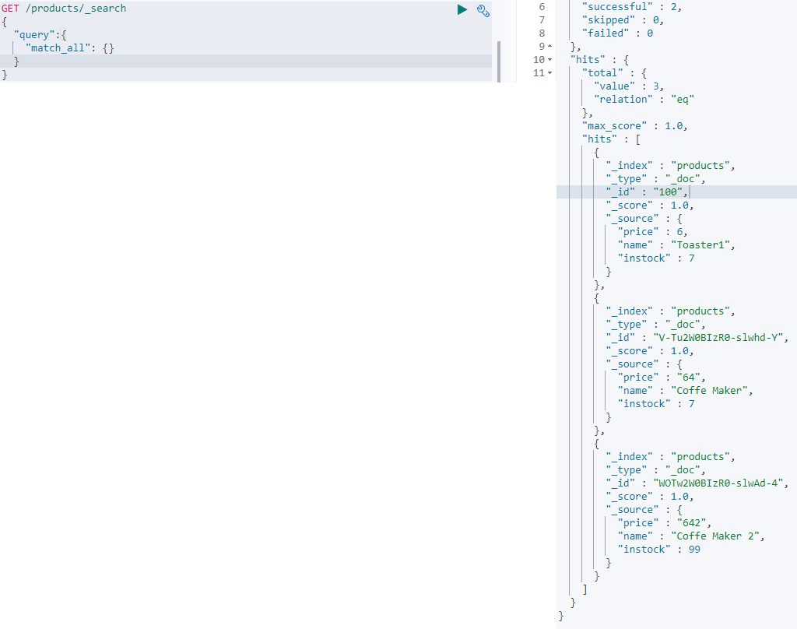

29. Delete documents based on condition

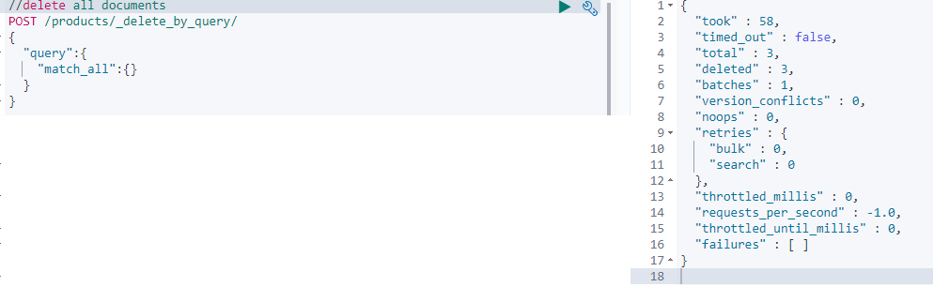

30. BATCH PROCESSING [create + index]

Endpoint : _bulk  
Actions : index / create / update /delete  
// Create action: will fail if the index already exists  
// Index action: will create doc if it does not exist, else it replaces  
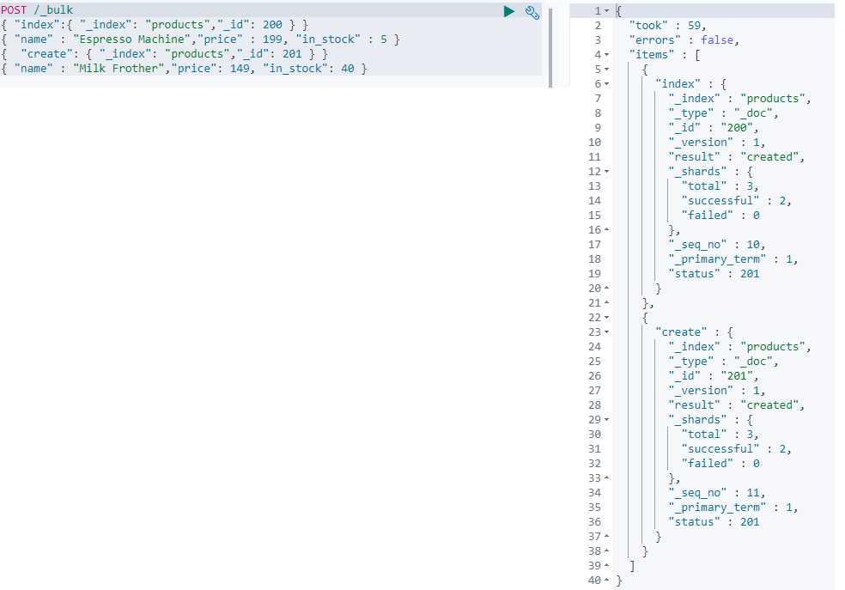  
Lets retrieve the results of the above command using a search query.  
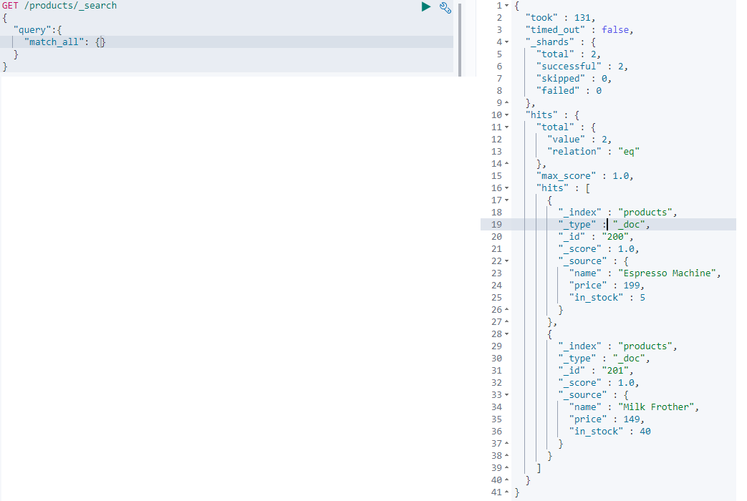

31. BATCH PROCESSING [update + delete]

Notice that if the index is same then – it can be given as part of the url instead as of a json object.  
The actions are all run against the products index.  
  
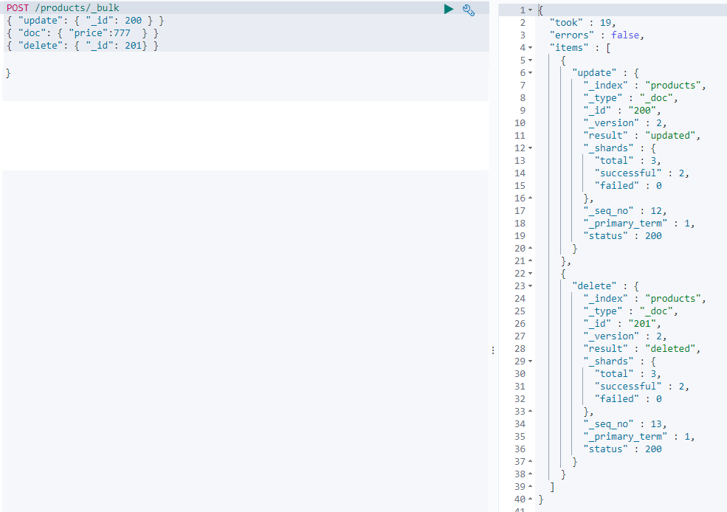  
  
Run the search query again.  
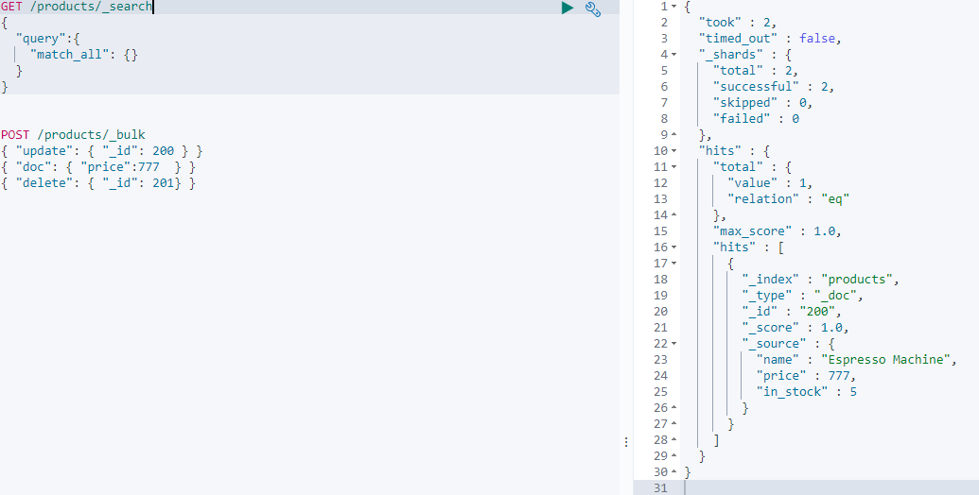

Note: when using the bulk API –

The content-Type: application/x-ndjson

Each line must end with /n or /r/n including the last line [hit enter for last line as well]

If an action fails other still will be executed

The bulk is useful when a lot of write actions are to be done.   
Note: The bulk api supports optimistic concurrency control- include the if_primary_term and if_seq_no with in the action metadata.

***32. Import Data into ES from a file using curl***

***curl -XPOST -u elastic: wp2ss2xAxTY5UnRUdgo2tUgW ‘http://24e374bd44bb4bf884cfd220f7f55cf0.ap-southeast-1.aws.found.io:9243/products/_bulk?pretty -H "Content-Type: application/x-ndjson" --data-binary "@products-bulk.json"  
Note : binary : curl removes new lines and binary is used to preserve the new line.***

Above command has problems  
So used: POST /products/_bulk command. + inserted the hwole content in the kibana editor

33. **MAPPINGS: HOW DOCUMENTS AND THEIR FIELDS SHOULD BE STORED AND INDEXED –** the point of doing this is **–** isto store andindex data in a way that is appropriate for how we want to search our data. [Something like schema for relational data bases –bad analogy ]

34. Dynamic Mapping:

ES has mapped the fields for us automatically.   
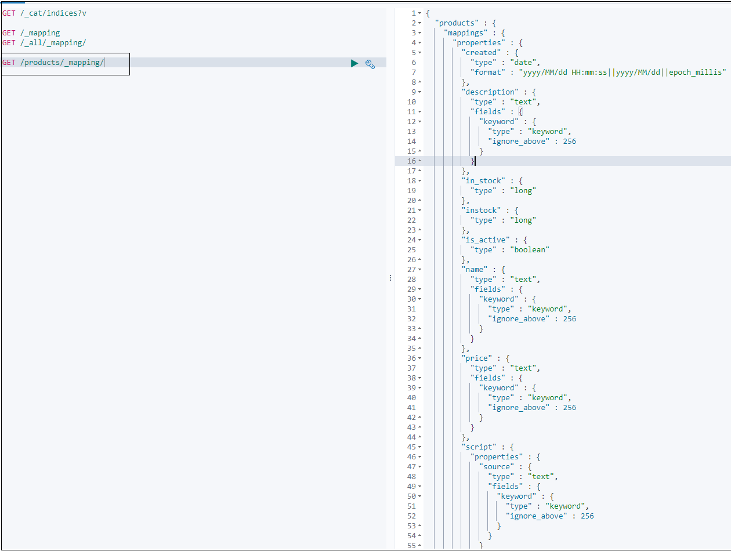

35. Meta Fields.

_index : This field is added to document automatically.  
 It simply contains the name of the index to which a document belongs.  
 It is used internally – when querying documents with in an index.

_id : stores the id of the document.

_source : contains the original source document.

_field_names : contains the name of every field.

_routing : stores the value used to route a document to a shard. [custom routing]

_version : used for versioning.

_meta : may be used to store custom data, that is left untouched by elastic search.

36. Filed Data Types. – core / complex /geo /specialized

**Core** **DATA TYPES**.

Text Data Type.

* Used to index full text value such as descriptions. They are **analyzed.**
* Due to the nature of full text fields they are rarely used in sorting and aggregating.
* Text fields are stored in a way for performing optimal searches.
* i.e text fields are used for text that we want to search.

Keyword Data Type.

* Typically used for sorting and aggregating.
* They contain text but not full text : that’s becoz they are not analyzed.
* Values are stored exactly as defined at the time of adding documents to an index.
* Ex : a field for storing email addrs, category field [filter documents to find products with in a given category].
* These fields are used for values that we want to filter or use for aggregations.

Numeric Data Types.

* Float / long / short / byte/ integer/ **scaled_float** / half_float / double

Date Data Type.

* Can be represented as String / integer in sec / long in millisec since epoch
* The date format that should be used for fields when supplying a string value can be configured.
* Else a default format is used : which can either be a sting that optionally contains time or num of milliseconds since the epoch.
* Internally dates are stored as a long value – representing the number of seconds since the epoch.

Boolean Data Type.

Binary Data Type.

Range Data Type.

* It is used for Date values such as Date ranges or integer intervals like 10 to 20.
* You define a upper and lower boundary when indexing a document, by using the keywords gt,gte,lt,lte
* There is a query named ‘range’ which utilizes this data type.

**COMPLEX DATA TYPES.**

Object data type.

* Used for storing objects – plain json objects
* They contain nested objects as well
* Let us say you have a person object like you see here. When you index the below object you supply a normal JSON object.  
  {  
   “name”:{  
   “firstname”:”Big”,  
   “lastname”:”Bo”

}  
“Profession”:”Software Engineer”  
}

* But Elastic search flattens the object when storing. This means internally the object contains only key value pairs. And any nested objects are handled by adding dots to the key names to preserve the hierarchy of the objects.

Array Data Type.

* Any field in elastic search may contain zero or more values by default. Such as an array of numbers, string, objects etc.
* That’s possible without us having to explicitly declare this.
* You can also have an array of arrays- but note that arrays are flattened when indexed.
* All values must be of the same data type.
* [1,[2,3]] -> [1,2,3]

Array of objects.

* You cannot query individual objects independently of the other objects in the array – that’s because of how Elastic search flattens objects, - which again is because Lucene has no concept of inner objects.
* Let us say we have to person objects with in an ARRAY + Each object consists 2 properties.
* {  
  “persons”::

[

{“name”: “One”, “age”:10},  
 {“name”: “Two”, “age”:20},  
 ]  
}

* When Elastic Search indexes this array of objects, it flattens this object – Thus we have multiple values for the same keys which are persons.name and persons.age. [The field value will now be an array]
* {  
   “persons.name”:[“One”,”Two”],  
   “persons.age”:[10,20]  
  }
* Notice that the association between the objects is lost.
* If we want to search for a person name **One** age **10** – we cannot find it. The values of the objects are mixed together. There is no way of distinguishing one from the other.

Nested Data Type.

* When using Nested Data type, Each object is indexed as a hidden document. Ensuring that each object is independent.
* We do however need to use nested queries when searching through the objects.
* What happens when running nested queries is that they are executed against the nested documents as if they were separate documents, which is actually the case internally .
* The point is the documents are independent from each other – so we can query an array of objects that we probably expected in the first place – because the association between object values is preserved with the ‘nested’ data type.

**GEO DATA TYPES.**

Used for geographical data – latitude and longitude pairs.

Geo-point Data Type.

* Accepts latitude and longitude pairs in 4 different formats.
* {  
   “Location”:{  
   “lat”:12.123456,  
   “lon”:13.345678  
   }  
  }
* String with lat and lon separated by a comma  
  {  
   “location”: “12.345678,-12.345678”  
  }
* Geo hash   
  {  
   “location”: ”8ber34hhaf4425”  
  }
* Inverse of option 2 lon,lat  
  {  
   “location”: “-12.345678, 12.345678”  
  }

Geo –Shape Data Type.

* To store more complex geographical data – use this
* This data type helps you to form shapes of geographical points.
* Ex: you can store space of a geographical forest, borders of a city.

**Specialized Data Types**

Used for storing ip address, attachments etc

IP Data Type.

* You typically query fields of this type using the cidr notation

Completion Data Type.

* This data type is about auto completion and search suggestions.
* That’s done with the help of suggesters – best approach.
* Using this data type enables very efficient lookups – as auto completion needs to be fast.
* Elastic search uses data structures that are slow to build but enables very fast lookups – and stores this in memory.

Attachment Data type.

* This data type is used for indexing documents that contain text and to make this text searchable
* Apache tika ..!?

36. **Adding mappings for new fields**

- Lets define a mapping for a new field named ‘discount’ with a data type of double

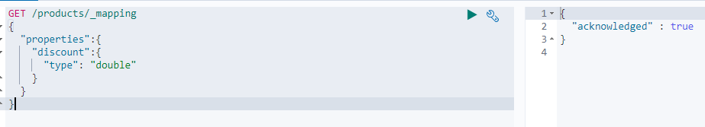  
- Lets verify the mappings

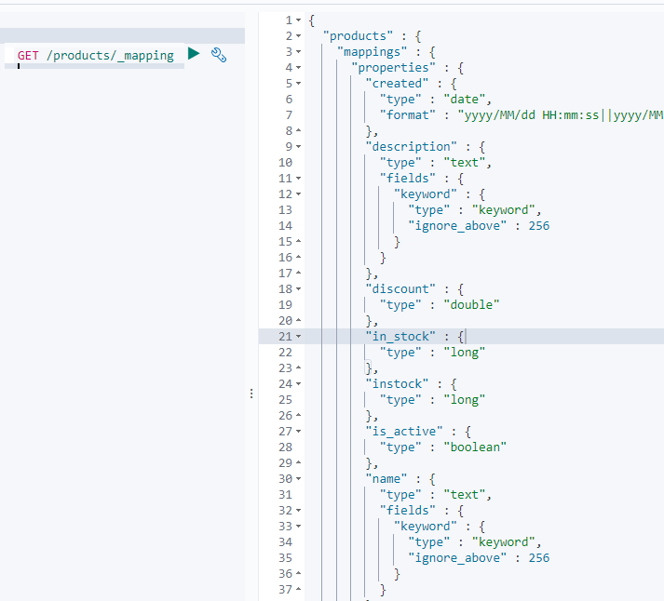

* Now documents with a discount field can be added.

37.

We get an error with the below query – we get an error that the type cannot be changed.  
Existing values for fields cannot be updated.

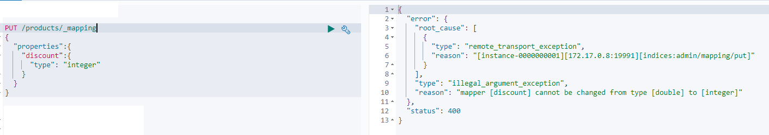

**What should be done ? [ **** changing existing mappings is not possible in elastic]**

* We should **delete the index**, create new mappings and re-index the data into the new index…



* Index gets created and mappings are added in the same query  
  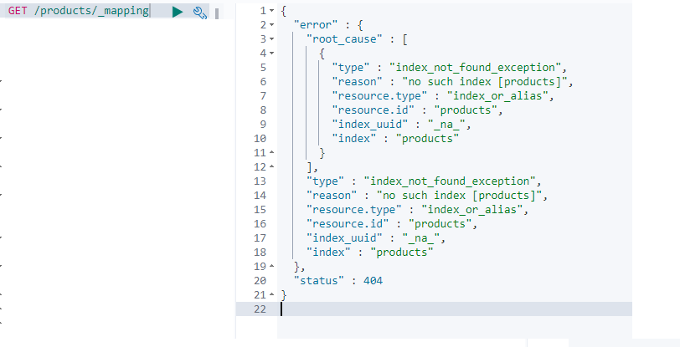
* Let’s first **add mappings for the simple data types**. [index will be created along with the mappings]  
  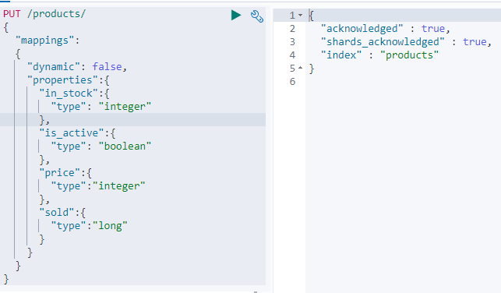  
  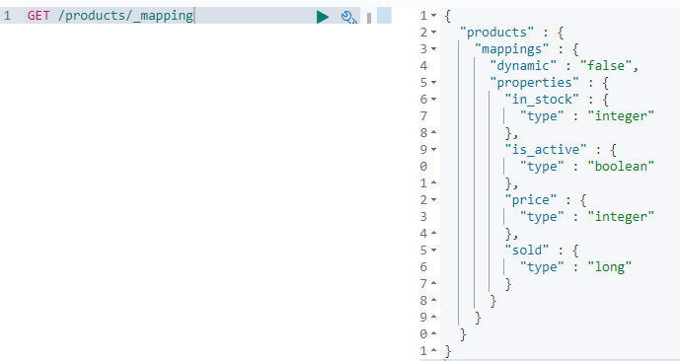  
  We shall not import the data yet.. as mappings for only the simplest fields have been added and mappings for other fields should also be added.
* There are few exceptions to the rules that mappings cannot be updated.

*You can add new properties for fields with the object data type*

*And you can also add additional mappings to existing fields.*

*An example of that is to add the keyword type to the text field.*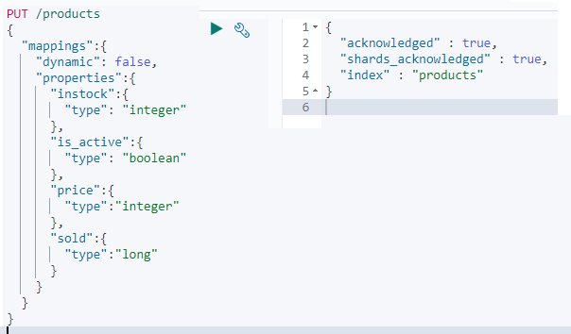

38. Properties that can be added to mappings.

Parameters that can be used to configure the mappings for fields.

**coerce parameter :** The data you index may come from various sources and it may not be in the same format you expect.ES handles this using coercion, - meaning that it convert values to the proper data type behind the scenes.  
Foe Ex : The document may contain “5” as a string for an integer field. Elastic search will try to clean up this data by coercing stings to numbers in this context.   
The above behavior can be disabled by setting the coerce parameter to false – in that case ES will reject documents that do not contain the correct data type.

**copy_to parameter:** This parameter enables us to build a custom parameter with fields that we choose.

For Example : we can specify that the first name and the last name field values to be copied to a field called full_name field.

{  
“first_name”: { “type”:”text” , ”copy_to”:”full_name” }  
“last_name”: { “type”:”text” , ”copy_to”:”full_name” }  
“full_name : { “type”:”text” }  
}

**NOTE : When using the copy to parameter – it’s the values of the fields that are copied and not the terms that are output by the analyzer used for the field. Copied values will not show up within the _source meta field.**

**properties parameter:**1. When adding a mapping when an index is getting created.  
2. It is used to map field mappings.

**norms parameter.**

When running search queries ES does not only determine whether or not a document matches: It also works on how well the document matches. – This is to give the user the most relevant search results first.   
{  
 “properties” :{  
 “full_name”:{  
 “type”:”text”,  
 “norms”:false  
 }  
 }  
}

Elastic search stores some information that enables calculating relevance scores.

i.e ES stores so called normalization factors for fields that have scoring enabled.

These factors are referred to as norms. The norms parameter can be used to disable this information.

This would save disk space, but then ES looses the ability to sort documents by relevance.

For fields that are used for aggregations or just filtering out documents and there by not scoring documents – that would not be an issue.

Note that we cannot recreate norms without re-creating index.

**Format parameter**

The format parameter is used for specifying the date fields.

This can be done by specifying a custom format in the JODA format or one of the formats that are built into ES.

Custom format : “yyyy-MM-dd”, “epoch_millis”, “epoch_second”,……

Default format : “strict_date_optional_time || epoch_millis” [The default format accept time with an optional time OR number of seconds since the epoch]

**null_value parameter**Replaces NULL values with the specified value.  
{  
 “properties”:  
 {  
 “discount”:  
 {  
 “type: “integer”,  
 “null_value”: 0   
 }

}  
}

**fields parameter.**

This parameter is used for indexing a field in different ways for different purposes.  
[did you notice the mapping that ES automatically added for us based on the test data that we have imported.]

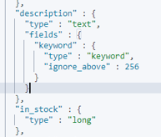

ES added an additional mapping with the “keyword” type for every “text” field.

The purpose of that is that you can use “text” fields for sorting and aggregation.

39. **ADDING MULTI-FIELDS MAPPINGS**

*Lets add more mappings for the* ***text fields*** – to do that we shall use the fields parameter to add additional keyword mappings and also the properties parameter.

Step 1:  
- if we need to add any parameters to a field say description you should do it with in the “description” object.  
- In this case we are not going to add a keyword mapping because that does not make sense.  
- Because we are not going to use the description field for any aggregations or any filtering that does not make any sense for a long field that contains many words.

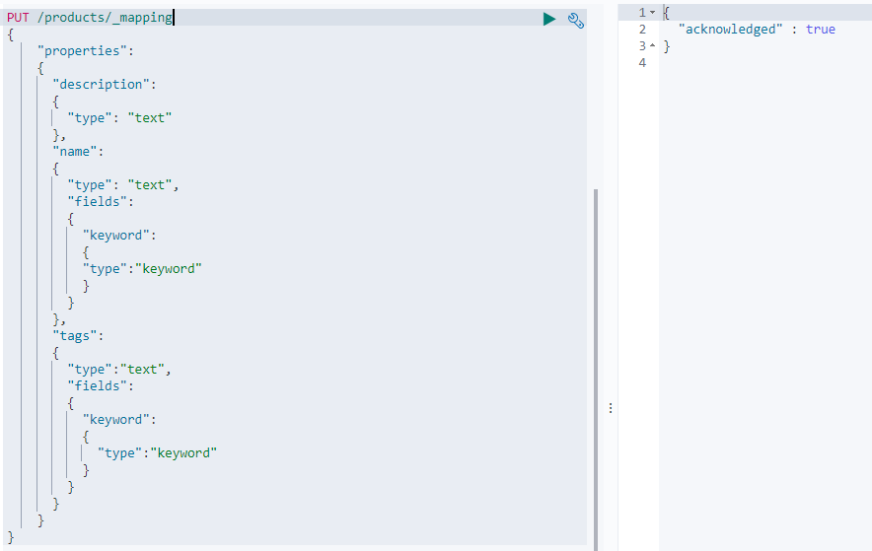  
Check if everything looks good.  
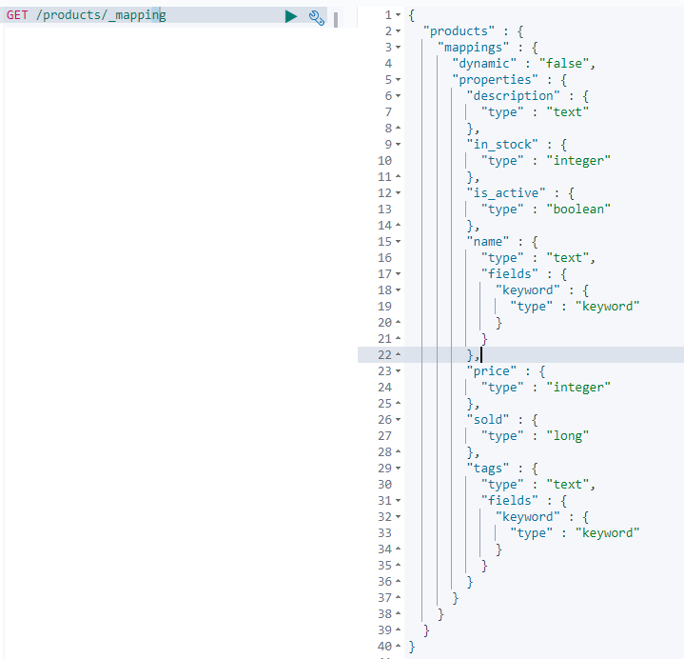

40. **Adding mapping for the created date field.**

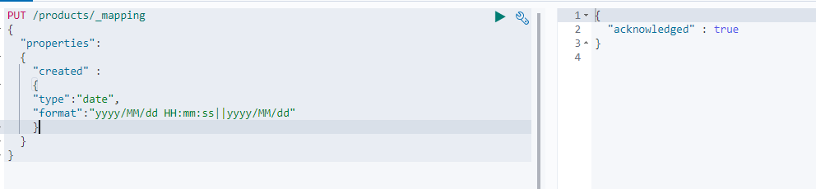  
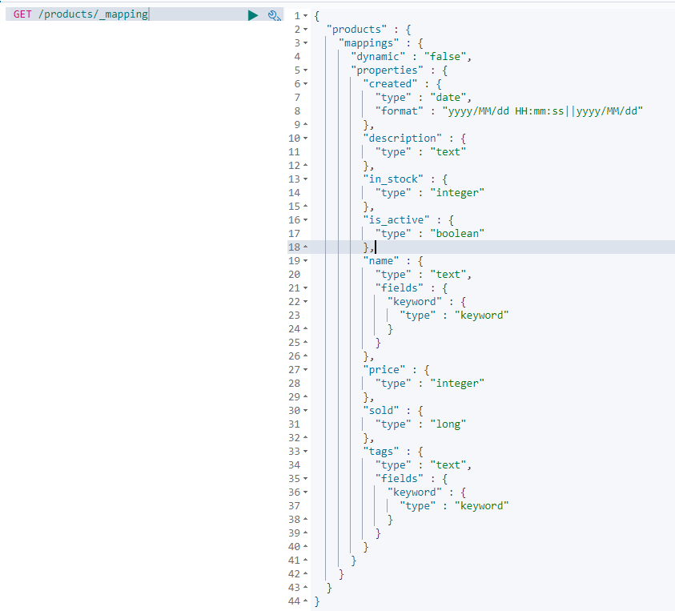

The default strict_date_optional_time expects date with dashes but not slashes.

41. Add the test data from the below file. Curl can be used + _bulk API can also be used.  
  


*Curl –H “Content-Type: application/json” –XPOST* [*http://localhost:9200/products/_bulk/pretty?*](http://localhost:9200/products/_bulk/pretty?) *–data-binary “@filename.json”*

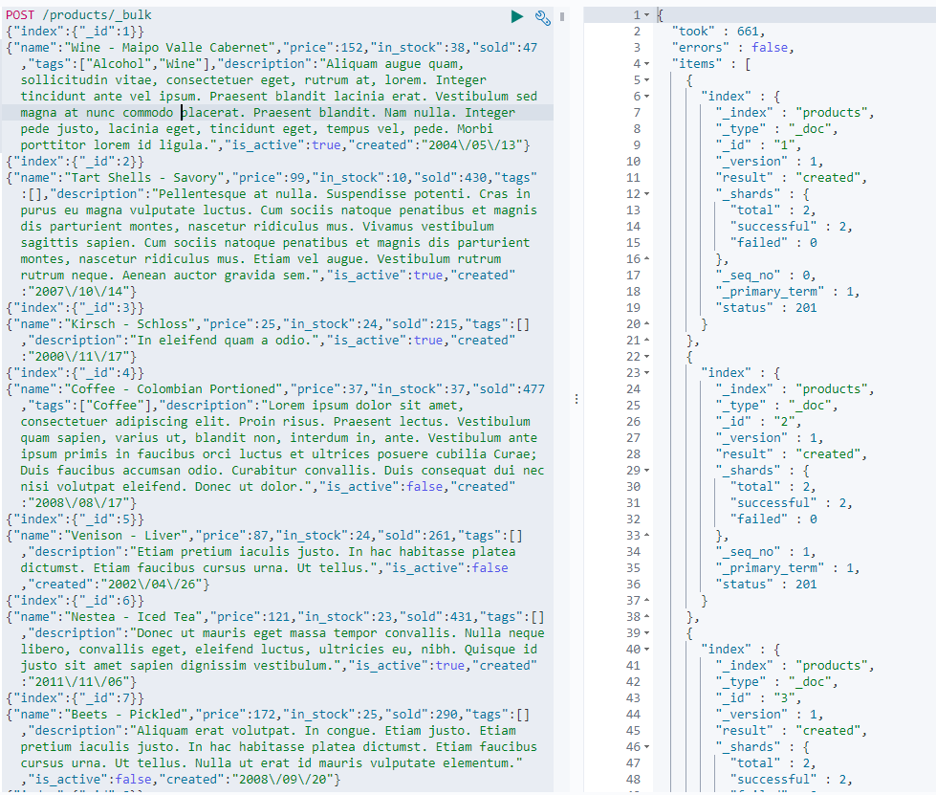

42. **PICKING UP NEW FIELDS WITHOUT DYNAMIC MAPPING**

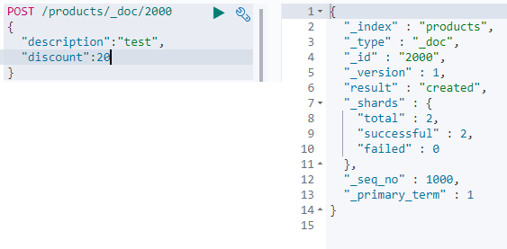   
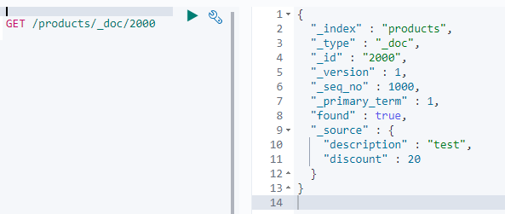

Add a mapping to the discount field – setting it to integer.  
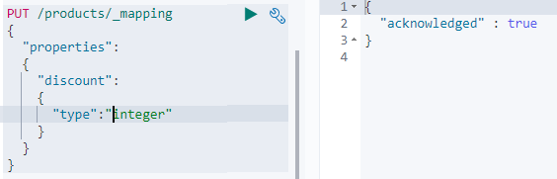  
  
Confirm if the document has been indexed correctly by performing a search query [search for “test” in the “description” field].  
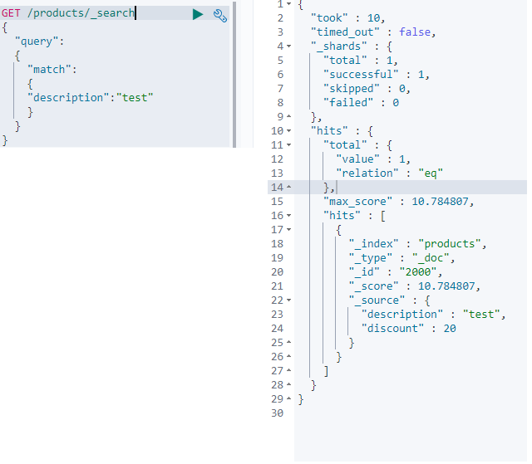

Let try to find the document by matching documents that a value of 20 for the discount field.  
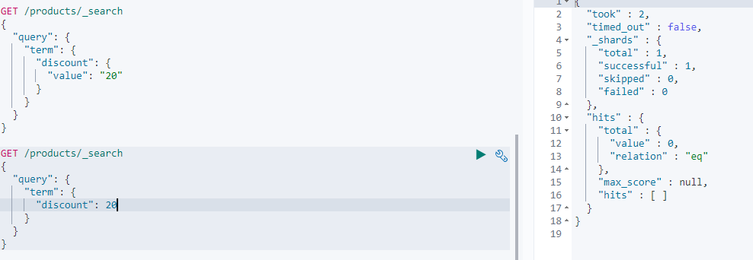

The document no longer matches.  
We have disabled dynamic mapping – through the “dynamic” parameter.  
**By doing that ES will just ignore fields for which there are no mappings.**[we can add mappings]  
The values will still be part of the _source meta field, But the values will not be indexed, and will therefore not be searchable.

Dynamic mapping being disabled is not that uncommon, and this is because we don’t want developers adding field mappings as they wish.

**Any Work around ?**

* We could just start over and add the mapping before adding our data.
* Use update_by_query api  
  This api performs an update on documents – in this case we will use it to pick up the mapping that we added for the discount field
* When the below query is run : it gets a snapshot of the current state of the index, if a given document was changed between the ‘start of the query’ and ‘when the query starts to update that particular document’ – we get a conflict as the version of the document no longer matches.
* 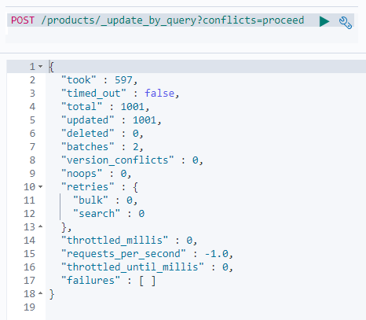
* The above query updated **all** of the documents in the index. It is also possible to add specific documents by adding a search query.
* The document has been re-indexed according to the new mapping, so the search query should match the new document now.  
  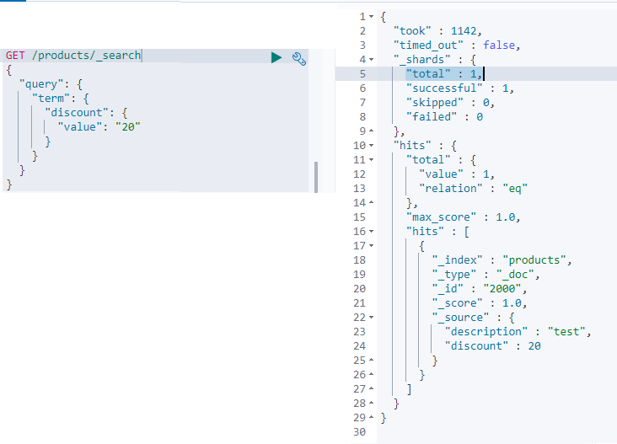
* Note : Since we disabled dynamic mapping for an index : ES ignored the discount field when adding a document containing that field. The field was still part of the source meta field but was not indexed and therefore not searchable.
* This is the reason the document was not matched by the search query, even after adding the mapping.
* When adding mappings we need to refresh documents, when not using dynamic mapping, by using the update_by_query api – which caused the new mapping to be picked up.
* 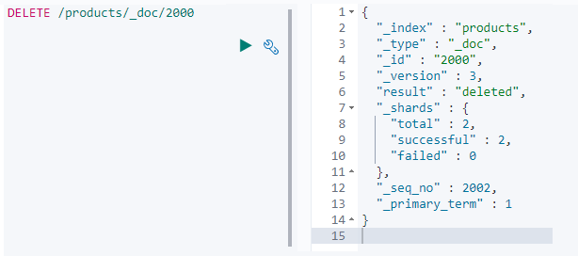

43. **Analyzers**